**POGODI TKO SAM**

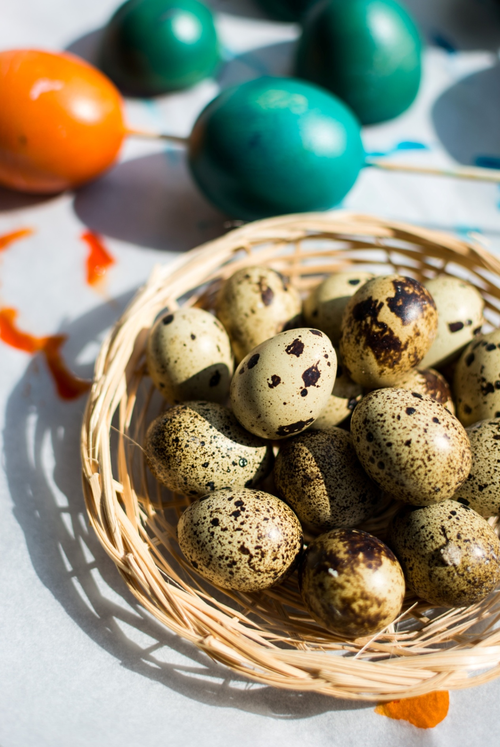

https://www.foodiesfeed.com/free-food-photo/easter-quail-and-regular-colored-eggs-2/

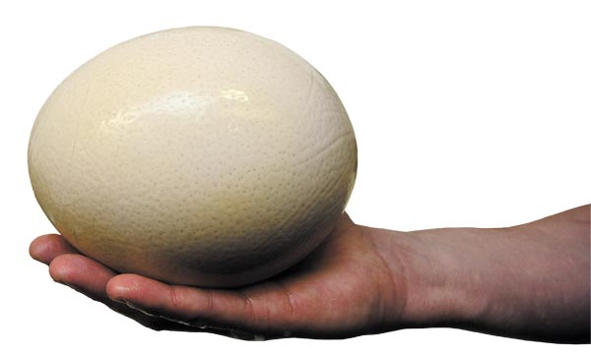

<https://chicagoreader.com/food-drink/key-ingredient-ostrich-egg/>

